Boxing Day

위에 있는 배경은 이 문제를 푸는 것과 연관이 없는 거 같아요.

Def read_boxes(text):

**>>>** boxes = read_boxes('boxes01.txt')

**>>>** boxes

{'guitar': 'conga', 'saxophone': 'banjo', 'conga': 'maracas', 'drum set': 'saxophone', 'trumpet': 'guitar', 'bass guitar': 'trombone', 'synthesizer': 'trumpet', 'banjo': 'drum set', 'trombone': 'bass guitar', 'maracas': 'synthesizer'}

Boxes01.txt는

guitar, conga

saxophone, banjo

conga, maracas

drum set, saxophone

trumpet, guitar

bass guitar, trombone

synthesizer, trumpet

banjo, drum set

trombone, bass guitar

maracas, synthesizer

이거입니다.

Read_boxes(text)는 이 boxes01.txt을 이용해서 딕셔너리를 만들어야 되는데 text의 각 줄 첫번쨰 단어는 key, 두번째 단어는 value로 만든다

#Assertion Error

**>>>** read_boxes('boxes02.txt') *# 2x same label*

Traceback (most recent call last):

AssertionError: invalid boxes

**>>>** read_boxes('boxes03.txt') *# 2x same content*

Traceback (most recent call last):

AssertionError: invalid boxes

**>>>** read_boxes('boxes04.txt') *# labels differ from contents*

Traceback (most recent call last):

AssertionError: invalid boxes

Boxes02.txt는

guitar, conga

saxophone, banjo

conga, maracas

drum set, saxophone

trumpet, guitar

bass guitar, trombone

synthesizer, trumpet

conga, drum set

trombone, bass guitar

maracas, synthesizer

keys가 중복될 때

Boxes03.txt는

guitar, conga

saxophone, banjo

conga, maracas

drum set, saxophone

trumpet, guitar

bass guitar, trumpet

synthesizer, trumpet

banjo, drum set

trombone, bass guitar

maracas, synthesizer

values가 중복될 때

Boxes04.txt는

guitar, conga

saxophone, banjo

conga, violin

drum set, saxophone

trumpet, guitar

bass guitar, trombone

synthesizer, trumpet

banjo, drum set

trombone, bass guitar

maracas, synthesizer

아예 다른 값(단어)가 있을 때

Def cycle(word, boxes):

일단 이 그림으로 바로 이해됐는데

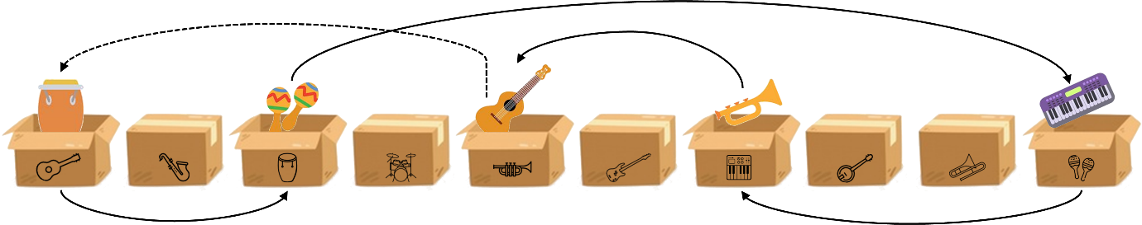

처음 word의 values가 key가 되고 그 key의 value가 또 key가 되고,,, 반복

**>>>** cycle('guitar', boxes)

('guitar', 'conga', 'maracas', 'synthesizer', 'trumpet')

**>>>** cycle('saxophone', boxes)

('saxophone', 'banjo', 'drum set')

**>>>** cycle('bass guitar', boxes)

('bass guitar', 'trombone')

**>>>** cycle('clarinet', boxes)

Traceback (most recent call last):

AssertionError: invalid item

“guitar”의 value는 “conga”, “conga”의 value는 “maracas”, “maracas”의 value는 “synthesizer”, “synthesizer”의 value는 “trumpet”인데 “trumpet”의 value가 “guitar”이어서 종료.

#AssertionError는 word가 boxes에 있는 단어가 아닐 때 invalid item

Def longest_cycle(boxes):

**>>>** longest_cycle(boxes)

5

Boxes의 모든 key값을 cycle(word, boxes)에 돌리고, 거기서 제일 긴 cycle의 횟수를 return